COMP0101 Requirements Engineering and System Architecture
Week 1 Exercises: Foundations

Problem statement: Radiation Therapy Controller
Radiation therapy is a type of cancer treatment where a patient receives high doses of radiation to kill cancer cells on a targeted body part. Radiations are delivered by a Radiation Therapy Machine (RTM) controlled by a radiation therapist.
The Radiation Therapy Controller is a software system whose purpose is to help ensure that the radiation delivered by the RTM are safe and conform to the doctor's prescription for the patient. The RTM is operated by a radiation therapist who must configure many RTM settings in order to deliver the prescribed treatment. The RTC can sense the RTM settings, but not control them. The role of the RTC is to ensure that the radiation beam can only be turned on when all RTM settings conform to the doctor's prescription. In addition, the RTC must log all radiation sessions so that details of each session can later be retrieved and consulted by doctors.
The radiation session prescriptions are stored in an external database that the RTC has read access to. The prescriptions are created by doctors treating the patient. Each prescription includes several different beam configurations called fields. Each field is defined by many machine settings.
The therapist operates the RTC at an ordinary workstation where they can initiate a new radiation session by selecting a prescription to be carried out. The actual turning on and off of the radiation beam is not done at the RTC workstation but at a separate control panel that has one START and one STOP button. These buttons are directly linked to a switch inside the therapy machine. The RTC merely senses the status of this switch. The configuration of all settings on the radiation therapy machine (such as those involved in setting the dose to be delivered, the positioning of the patient and the positioning of the moveable part of the machine) is done by the therapist directly on the radiation therapy machine.
The RTC is responsible for checking that the prescribed settings and actual settings agree. It does so by controlling another switch inside the radiation therapy machine. The radiation beam can be on only when this switch is closed. The RTC therefore indicates that the prescribed settings have been achieved by closing this switch.
When a patient arrives, the therapist selects the relevant patient’s prescription and the RTC displays the required settings associated to the prescription. Then, the therapist enters the treatment room to position the patient and set up the machine. When all settings match the prescription, the RTC closes its switch and the RTC display indicates that the machine is ready to begin treatment. The therapist leaves the treatment room, presses the START button, and the beam turns on. It usually remains on until the prescribed dose is delivered, and then turns off automatically when a dosimeter opens its switch in the interlock chain. When the beam stops, the RTC stores information about the radiation session that has just been carried out in an external Radiation Session database. For each radiation session, the RTC must store the times at which the beam has been turned on and off, the patient to which the session was applied, the prescription that was executed, and all machine settings used during the session.
There can be many exceptions to this usual sequence. The therapist may select a different patient and patient’s prescription at any time, except when the beam is actually on. The therapist can always turn off the beam by pressing the STOP button before the prescribed dose is delivered (for example, if the patient moves). Other safety control programs or the hardware safety circuit can also open their switch in the interlock chain if they detect any fault. This will also turn off the beam.
References
[1] Jacky, J., Unger, J., Patrick, M., Reid, D., and Risler, R. 1997. Experience with Z Developing a Control Program for a Radiation Therapy Machine. In Proceedings of the 10th international Conference of Z Users on the Z Formal Specification Notation (April 03 - 04, 1997). J. P. Bowen, M. G. Hinchey, and D. Till, Eds. Lecture Notes In Computer Science, vol. 1212. Springer-Verlag, London, 317-328.
[2] Jacky, J. 1996 The Way of Z: Practical Programming with Formal Methods. Cambridge University Press.

Context diagram and domain scenario
Figure 1 shows a context diagram for the radiation therapy controller. We will study context diagram next week. For the moment, you can read it as an informal figure showing the actors involved in the system and their interactions.
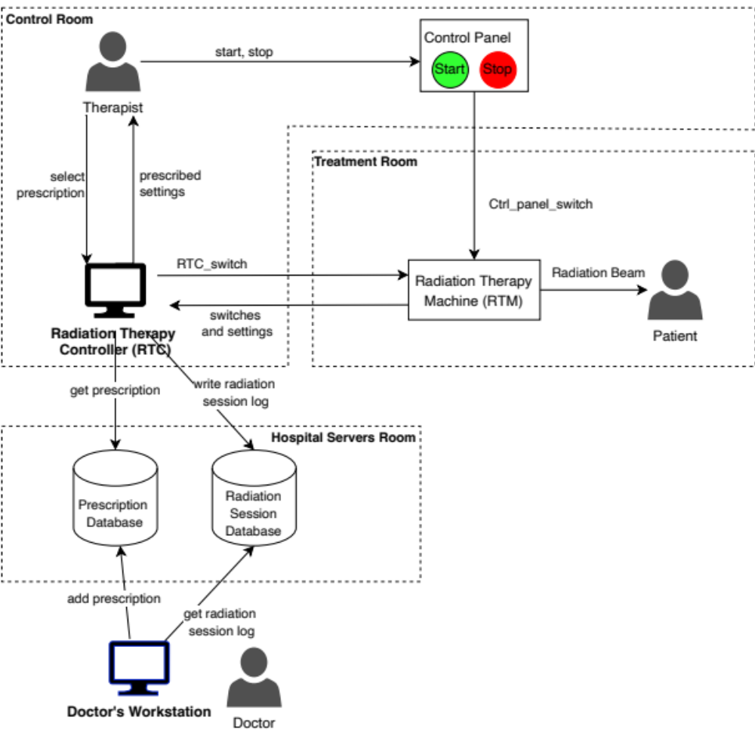
Figure 1. Context diagram for the Radiation Therapy Controller

A typical scenario where a patient has a normal a radiation session is given below. The context and outcome describe the state of the world at the start and end of the scenario, respectively.

Scenario A patient has a normal radiation therapy session
Context:
- A doctor has written a prescription for a patient's radiation session.
- The prescription is held in the prescription database.
Outcome:
- The patient has received a radiation session that conforms to the prescription.
- The radiation session is logged in the radiation session database.
Sequence of events:
- A patient arrives to their radiation session and is met by a therapist.
- The therapist checks the patient identity by asking their name and date of birth.
- The therapist selects the patient's prescription on the RTC workstation.
- The RTC displays the required RTM settings associated with the prescription.
- The therapist and patient enter the treatment room where the RTM is located.
- The therapist positions the patient and configures the RTM according to the required settings.
When the RTM settings match the prescription:
- The RTC closes the RTC_switch in the RTM.
- The RTC displays that treatment is ready to begin.
- The therapist leaves the treatment room.
- The therapist presses the START button on the control panel.
- The radiation therapy machine's beam turns on.
When the prescribed dose is delivered:
- The radiation therapy machine's beam turns off automatically (the dosimeter switch opens).
- The RTC stores all information about the radiation session in the radiation sessions database.

Question 1. Actors and Stakeholders
Which of the following terms denote actors and stakeholders for this system?
Term | Actor  (Y or N) | Stakeholder  (Y or N)
Doctor | N | Y
Therapist | Y | Y
Patient | N | Y
Radiation Therapy Machine | Y | N
Radiation Therapy Controller | N | N
Radiation Session | N | N
Prescription | N | N
Hospital Management Team | N | Y
Medical Safety Regulator and Inspectors | N | Y
- The doctor does not interact directly with the RTC, because they create prescriptions that the RTC reads from an external system.
- The therapist is an actor because they interact directly with the RTC by selecting patient’s prescription on its workplace
The therapist is also a stakeholder because their ability to deliver treatment safely depends on the RTC working correctly.
- Patient does not interact directly with RTC, but their health and safely are affected by whether RTC ensures that treatment conforms to prescription.
- RTM is an actor because it interacts directly with the RTC though machine settings and control signals. It is not a stakeholder because it is a physical device with not interests of its own.
- RTC is not an actor because it is system being analysed. It is not a stakeholder too because it is a software sys with no interests of its own.
- A radiation session is neither an actor nor a stakeholder because it is a treatment activity, not an external interacting entity or a person who has an interest in the sys.
- A prescription is neither an actor nor a stakeholder because it is information (recipe) used by RTC and has no interests of its own.
- Management team is not an actor because the scenario does not describe them interacting directly with RTC. They are stakeholders because the RTC’s correct operation affects whether the treatment succeeds or fails.
- Medical safety regulators and inspectors are not actors because they do not interact directly with RTC, but they are stakeholders because they have an interest in ensuring that the system meets medical safety requirements.

Question 2. Phenomena
Use the context diagram and your understanding of the problem statement to classify phenomena from the scenario as world phenomenon (W), machine input (I), machine output (O), or internal machine phenomenon (M). Use the most specific type only, i.e. for a machine input or output, you don't need to write that it is also world phenomena.
The Machine is the Radiation Therapy Controller (RTC).
Phenomena Description | Phenomena Type  (W, I, O, M)
A doctor writes a prescription for a patient's radiation session | W
1. A patient arrives for a radiation session | W
2. The therapist checks the patient identity by asking their name and date of birth | W
3. The therapist selects the patient's prescription on the RTC workstation. | I
4. The RTC displays the required RTM settings associated with the prescription | O
5. The therapist and patient enter the treatment room where the RTM is located | W
6. The therapist positions the patient and configures the RTM according to the required settings. | W
The RTM switches and settings | I
7. The RTC closes the RTC_switch in the RTM | O
8. The RTC displays that treatment is ready to begin | O
9. The therapist leaves the treatment room | W
10. The therapist presses the START button on the control panel | W
11. The radiation therapy machine's beam turns on | W
12. The radiation therapy machine's beam turns off | W
13. The RTC stores all information about the radiation session in the radiation sessions database | O

Question 3. Domain goals
Consider the following two domain goals.
G1. Achieve [Radiation Session Delivered]
When a patient attends a radiation session, they should eventually leave the session having received the radiation treatment prescribed by their doctor.
G2. Avoid [Incorrect Radiation Delivery]
When a patient attends a radiation session, they should not receive radiation that deviates from the doctor’s prescription.
2.1. Do these two goals describe the same property or two different properties? Can you think of behaviours that satisfy one goal and not the other?
I think there are two different properties because G1 requires the patient to eventually receive the prescribed treatment, while G2 requires that no incorrect radiation be delivered.
For example, a patient leaving the session without receiving and radition satifies G2 but not G1.

2.2. List the world phenomena referenced in G1.
- Patient attending a radiation session.
- Patient leaving the radiation session.
- The treatment prescribed by the patient’s doctor

2.2. List the world phenomena referenced in G2.
- Patient attending a radiation session.
- Patient receiving radiation.
- The treatment prescribed by the patient’s doctor.
- The delivered radiation deviating from doctor’s prescription.

2.3. Optional: you won't be assessed on formal specification, but doing this exercise can help you understand the concepts of phenomena and properties, and ultimately write better requirements.
Formulate the domain goals G1 and G2 in temporal logic using the following patterns:
Goal Pattern | Temporal Logic Pattern | Meaning
Achieve | P => <> Q  (read: "P implies eventually Q") | If P is true at some time t0, then Q will be true at some later time t1 (t1 >= t0).
Avoid | P => [] not Q  (read: "P implies always not Q") | If P is true at some time t0, then Q will be false for all times t1 later or equal to t0 (t1 >=t0)
In these patterns, P and Q are logical formula: they can be conjunction ("and") and disjunction ("or") of several atomic propositions or predicates.
G1 – Achieve [Radiation Session Delivered]
Let P = Patient attends a radiation session.
Let Q = Patient leaves the session AND has received the radiation treatment prescribed by their doctor.
ANS: P => <> Q

G2 – Avoid [Incorrect Radiation Delivery]
Let P = Patient attends a radiation session.
Let Q = Patient receives radiation that deviates from the doctor’s prescription.
ANS: P => [] not Q

Question 4. Goals, requirements, and assumptions.
4.1. Classify each of the following properties as the formulation of a domain goal (G), a domain assumption (D), or a machine requirement (R). Use the most specific type only: if the property is a domain assumption or machine requirement, you don't need to say that it is also a goal.
ID | Property | Type (G, D, or R)
3 | When a patient arrives for a radiation session, the therapist will select the patient's prescription on the RTC workstation. | D
4 | When the therapist selects a prescription, the RTC displays the required RTM settings associated with the prescription. | R
5 | After the therapist has selected a prescription and the RTC displayed the required RTM settings, the therapist will position the patient and configure the RTM according to the required settings. | D
6 | While the RTM setting do not conform to the selected prescription, the RTC switch should remain open. | R
7 | When the RTM settings conform to selected prescription, the RTC should close its switch and indicate that the machine is ready to begin treatment. | R
8 | When the RTC display indicates the machine is ready to begin treatment, the therapist should press the START button on the control panel. | D
9 | The radiation beam is produced by the radiation therapy machine only if all switches are closed. | D

4.2. For any property that you have classified as a machine requirement, list the world phenomena involved in the property and, for each phenomenon, state whether it is a machine input or machine output.
Property ID | World phenomenon | Ans
4 | Therapist’s selection of the patient’s prescription | I
4 | The prescribed RTM settings read from the external prescription database | I
4 | The required RTM settings displayed by the RTC | O
6 | The actual RTM settings sensed by the RTC | I
6 | The selected prescription and its prescribed RTM settings | I
6 | RTC switch being kept open | O
7 | The actual RTM settings sensed by the RTC | I
7 | The selected prescription and its prescribed RTM settings | I
7 | RTC switch being closed | O
7 | Treatment-ready status displayed by the RTC | O

Question 5. Requirements Correctness
Consider again the goals G1 and G2.
G1. Achieve [Radiation Session Delivered]
When a patient attends a radiation session, they should eventually leave the session having received the radiation treatment prescribed by their doctor.
G2. Avoid [Incorrect Radiation Delivery]
When a patient attends a radiation session, they should not receive radiation that deviates from the doctor’s prescription.

5.1. Write a list of domain assumptions D and a list of machine requirements R that contribute to G1 (D, R ⊢ G1). Do not include domain assumptions and machine requirements that do not contribute to G1.
Domain assumptions (D):
- Therapist selects the correct prescription, positions the patient, configures the RTM correctly and presses START button when ready.
- Prescription data and sensed RTM settings are accurate, and the settings remain correct during treatment.
- Other interlock permit treatment. When START button is pressed and all switches are closed, the RTM delivers the prescribed dose and stops automatically. The patient then leaves.
Machine requirements (R):
- RTC displays the settings required by the selected prescription.
- When actual settings match the prescription, RTC closes its switch and displays that treatment is ready.

5.12 Write a list of domain assumptions D and machine requirements R that contribute to G2 (D, R ⊢ G2). Do not include domain assumptions and machine requirements that do not contribute to G1.
Domain assumptions (D):
- The selected prescription belongs to the current patient and prescription data, and sensed RTM settings are accurate.
- RTM produces radiation only when all interlock switches are closed.
- Radiation delivery follows the actual RTM settings, and the dosimeter stops irradiation at the prescribed dose.
Machine requirements (R):
- RTC keeps its switch open unless the actual RTM settings match the selected prescription.
- RTC continuously monitors the settings and opens its switch immediately if a mismatch occurs.
- RTC prevents changes to the selected patient or prescription while the beam is on.

